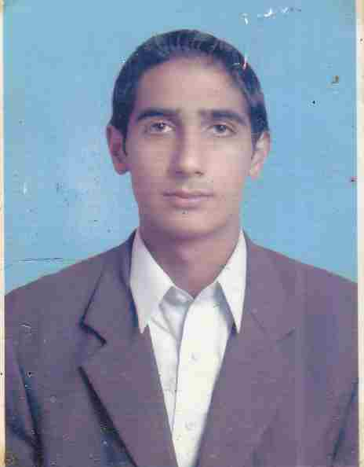
Resume

hakum ali
Cell No: 0092 3135870380
Cell No: +971-52-9422191
E-Mail ID:- hhakamali@ymail.com

Objective:

To join a dynamic and progressive organization offering ample opportunities for diversified experience, and seeking a position which will allow for continued professional growth, offering an environment in which advancement is based on strength of individual contributions to the realization of organizational goals.

Educational Record

Degree | Year | Division | Institution/ Board
Metric | 2006 | 2nd | Govt. High School kholian bala haripur.
DAE (TELECOM) | 2009 | 1ST | GPI Haripur

Computer Skills:

- Good Knowledge in Office management
- Good Knowledge in MS Office
- Good Knowledge in Typing

Other Education and Skills:

No. | Course Name | Company/institute
1. | 1 Year Welding Course | AGT Institute of Technical Professional Education Pakistan.
2 | SSEI  Short Service Employee 1 | Gulf Piping Company W.L.L.

3 | 3 Days Orientation Course in Safe Work Practices | Gulf Piping Company W.L.L.
4 | BBSM  (Observation Course) | Gulf Piping Company W.L.L.
5 | Tig Welding 6G | Gulf Piping Company W.L.L.
6 | Stick Welding 6G | Gulf Piping Company W.L.L.

Experience
Have 05 years experience in Maintenance , Erection, Fabrication, & Structure work Pakistan & Middle East.
Good knowledge & Familiar standards and codes;
Argon and Stick Welding for Piping and Structure .
Material:
CARBON STEEL, STAINLESS STEEL, INCONEL, CALD, DUPLIX, SUPER DUPLIX, CUNI, NIKLE.

Company : Gulf Piping Company W.L.L. Abu Dhabi (UAE)

Designation: Welder, Grinding, Cutting, Gouging, and Taker 25-01-13 to till now.

During this period I am working in below projects:

- Fatima Fertilizer Phase 2 Pakistan
- Fouji Cement Factory Wah Cantt Pakistan
- Ghazi Brotha Power Project Pakistan
- Sagar Smart Rig India
- Accommodation Barge Abu Dhabi
- Oil Bouys A & B G.P.C
- Personal Use Barge G.P.C. Abu Dhabi
- NDC drilling Rig Alyasat GPC
Work in Pipe Shop, Field, Erection and inside the confined space also.

Responsibility:

Worked in above projects in Maintenance, Erection, Structure, consumable material for welding.

- KNOWLEDGE ABOUT:

- CUTTING, Grinding, Gouging.
- EXPERT IN PLAZMA CUTTING TO CUT SS AND INCONAL, DUPLEX AND SUPER DUPLEX.
- OXY GAS CUTTING WITH HELP OF D.A. & PROPEN EXPERT IN MANUAL AND AUTO CUTING MACHINE SUCH AS A BAVEL AND TREAN TYPE.
- CONFIND SPACE MADICALLY FIT TO WORK IN CONFIND SPACE.
- taker for argon and stick welding.

RIGGING AND LIFTING.

- EXPERT IN RIGGING WITH STANDAR, NON STANDARD AND CRITICAL LIFITING. FOLLOW UP STANDARD SLINGS WIRES.

Hobbies:-

- Playing Cricket and Traveling
- Survive with Critical Activities.
- Driving.

Personal Profile:

Father’s Name | : | Khaliq Dad Khan
Mother’s Name | : | Naseem akhatr
Date of birth | : | 02-01-1990
Religion | : | Islam
Nationality | : | Pakistani
N.I.C # | : | 1310126846029
Passport # | : | YN1796021
Issue date | : | 13 oct 2010
Expiry date | : | 13 oct 2015
Place of issue | : | Pakistan
Visa status | : | Employment
Domicile | : | Abbottabad(Kpk)
Marital status | : | Single
|Languages | : | English, Urdu, Punjabi & Hindi
Permanent Address in Pakistan | : | Village: chamba  Post Office. chamba  Tehsil. Havelian  Distt. Abbottabad  Kpk, Pakistan
In Abu Dhabi | : | GULF PIPING COMPANY W.L.L.  MUSAFFA INDUSTRIAL AREA STREET# 41 HAKUM ALI  B # 10001116
+971-52- 9422191 P.O.Box. 2739

